Experiment – 2.2.1
Student Name: Himanshu Goyal | UID: 24BDA70369
Branch: CSE (Data Science) | Section/Group: 24 BDS-4(B)
Course: Full Stack II (24CSP-337) | Date of Performance: 16-09-2026

1. Aim:
To implement paginated and sortable REST APIs for efficient and scalable data retrieval.
2. Software Required:
• Programming Language: Java (JDK 17 or higher)
• Framework: Spring Boot 3.x / 4.x (Spring Data JPA, Spring Web)
• IDE / Environment: Visual Studio Code with Java Extension Pack / IntelliJ IDEA
• API Testing Tool: Postman / Windows PowerShell Invoke-RestMethod
• Relational Database: In-Memory H2 Relational Database / PostgreSQL
3. Objectives:
• To understand pagination and sorting concepts: slicing large datasets into bounded sub-collections.
• To implement pageable APIs using Spring Data: leveraging Pageable, PageRequest, Sort, and Page<T> abstractions.
• To optimize data retrieval for large datasets: preventing server memory exhaustion and network congestion.
• To improve API performance and usability: providing rich navigational metadata (totalPages, hasNext, isFirst).
• Course Outcomes Mapped: CO3 - BT3, CO4 - BT4
4. Theory:
In enterprise web platforms and content feeds, datasets continually expand to tens of thousands or millions of records. Retrieving all records in a single unbounded API query (such as findAll()) produces severe database lock contention, memory exhaustion (OutOfMemoryError), and unacceptable network bandwidth consumption.
Pagination systematically resolves this bottleneck by dividing datasets into discrete, bounded segments (pages). Clients specify the page index (zero-based) and the desired page size. Sorting allows clients to order records by specific attributes (e.g., createdAt, title, popularity) in ascending (ASC) or descending (DESC) directions. Spring Data provides direct support via the Pageable and Sort abstractions, which translate queries into optimized SQL LIMIT and OFFSET statements executed natively in the database engine.
To deliver optimal client developer experience, responses are encapsulated in a specialized PagedResponse<T> wrapper containing navigation flags: totalElements, totalPages, pageNumber, pageSize, isFirst, isLast, hasNext, and hasPrevious. This allows frontend components to render dynamic pagination controls, infinite scrolling feeds, and sort indicators with complete fidelity.
5. Procedure / Algorithm:
• Step 1: Define repository methods accepting Pageable parameters: findWithFilter(PostStatus status, String keyword, Pageable pageable).
• Step 2: Expose GET /api/v1/posts endpoint with query parameters: page, size, sortBy, direction.
• Step 3: Apply input bounds: @Min(0) for page index and @Min(1) @Max(100) for page size to prevent denial-of-service allocations.
• Step 4: Construct Pageable instance: PageRequest.of(page, size, Sort.by(sortDirection, sortBy)).
• Step 5: Query repository and transform domain entity Page<Post> to DTO Page<PostResponse> using PostMapper.
• Step 6: Encapsulate results in standardized PagedResponse<PostResponse> with complete pagination metadata.
• Step 7: Wrap PagedResponse inside generic ApiResponse.ok(pagedResponse) for consistent envelope architecture.
• Step 8: Verify zero-index pagination, sorting orders, and boundary conditions via automated MockMvc integration tests.
6. Code and Output:
Listing 1: Paginated & Sortable Endpoint in PostController
@GetMapping
public ResponseEntity<ApiResponse<PagedResponse<PostResponse>>> getPosts(
@RequestParam(required = false) PostStatus status,
@RequestParam(required = false) String keyword,
@RequestParam(defaultValue = "0") @Min(value = 0, message = "Page index must be >= 0") int page,
@RequestParam(defaultValue = "10") @Min(value = 1, message = "Page size must be >= 1")
@Max(value = 100, message = "Page size must be <= 100") int size,
@RequestParam(defaultValue = "createdAt") String sortBy,
@RequestParam(defaultValue = "desc") String direction) {
Sort.Direction sortDirection = "asc".equalsIgnoreCase(direction) ? Sort.Direction.ASC : Sort.Direction.DESC;
Pageable pageable = PageRequest.of(page, size, Sort.by(sortDirection, sortBy));
Page<PostResponse> postPage = postService.getPosts(status, keyword, pageable);
PagedResponse<PostResponse> pagedResponse = PagedResponse.of(postPage);
return ResponseEntity.ok(ApiResponse.ok(pagedResponse, "Posts fetched successfully"));
}

Listing 2: Service Layer Page Retrieval & Standardized PagedResponse Envelope
@Override
@Transactional(readOnly = true)
public Page<PostResponse> getPosts(PostStatus status, String keyword, Pageable pageable) {
String trimmedKeyword = (keyword != null && !keyword.trim().isEmpty()) ? keyword.trim() : null;
Page<Post> postPage = postRepository.findWithFilter(status, trimmedKeyword, pageable);
return postPage.map(postMapper::toResponse);
}
// PagedResponse standard envelope
public record PagedResponse<T>(
List<T> content,
int pageNumber,
int pageSize,
long totalElements,
int totalPages,
boolean isFirst,
boolean isLast,
boolean hasNext,
boolean hasPrevious
) {
public static <T> PagedResponse<T> of(Page<T> page) {
return new PagedResponse<>(
page.getContent(),
page.getNumber(),
page.getSize(),
page.getTotalElements(),
page.getTotalPages(),
page.isFirst(),
page.isLast(),
page.hasNext(),
page.hasPrevious()
);
}
}

Output 1: Page 0 Retrieval with Bounded Size (2 records) and Navigational Metadata
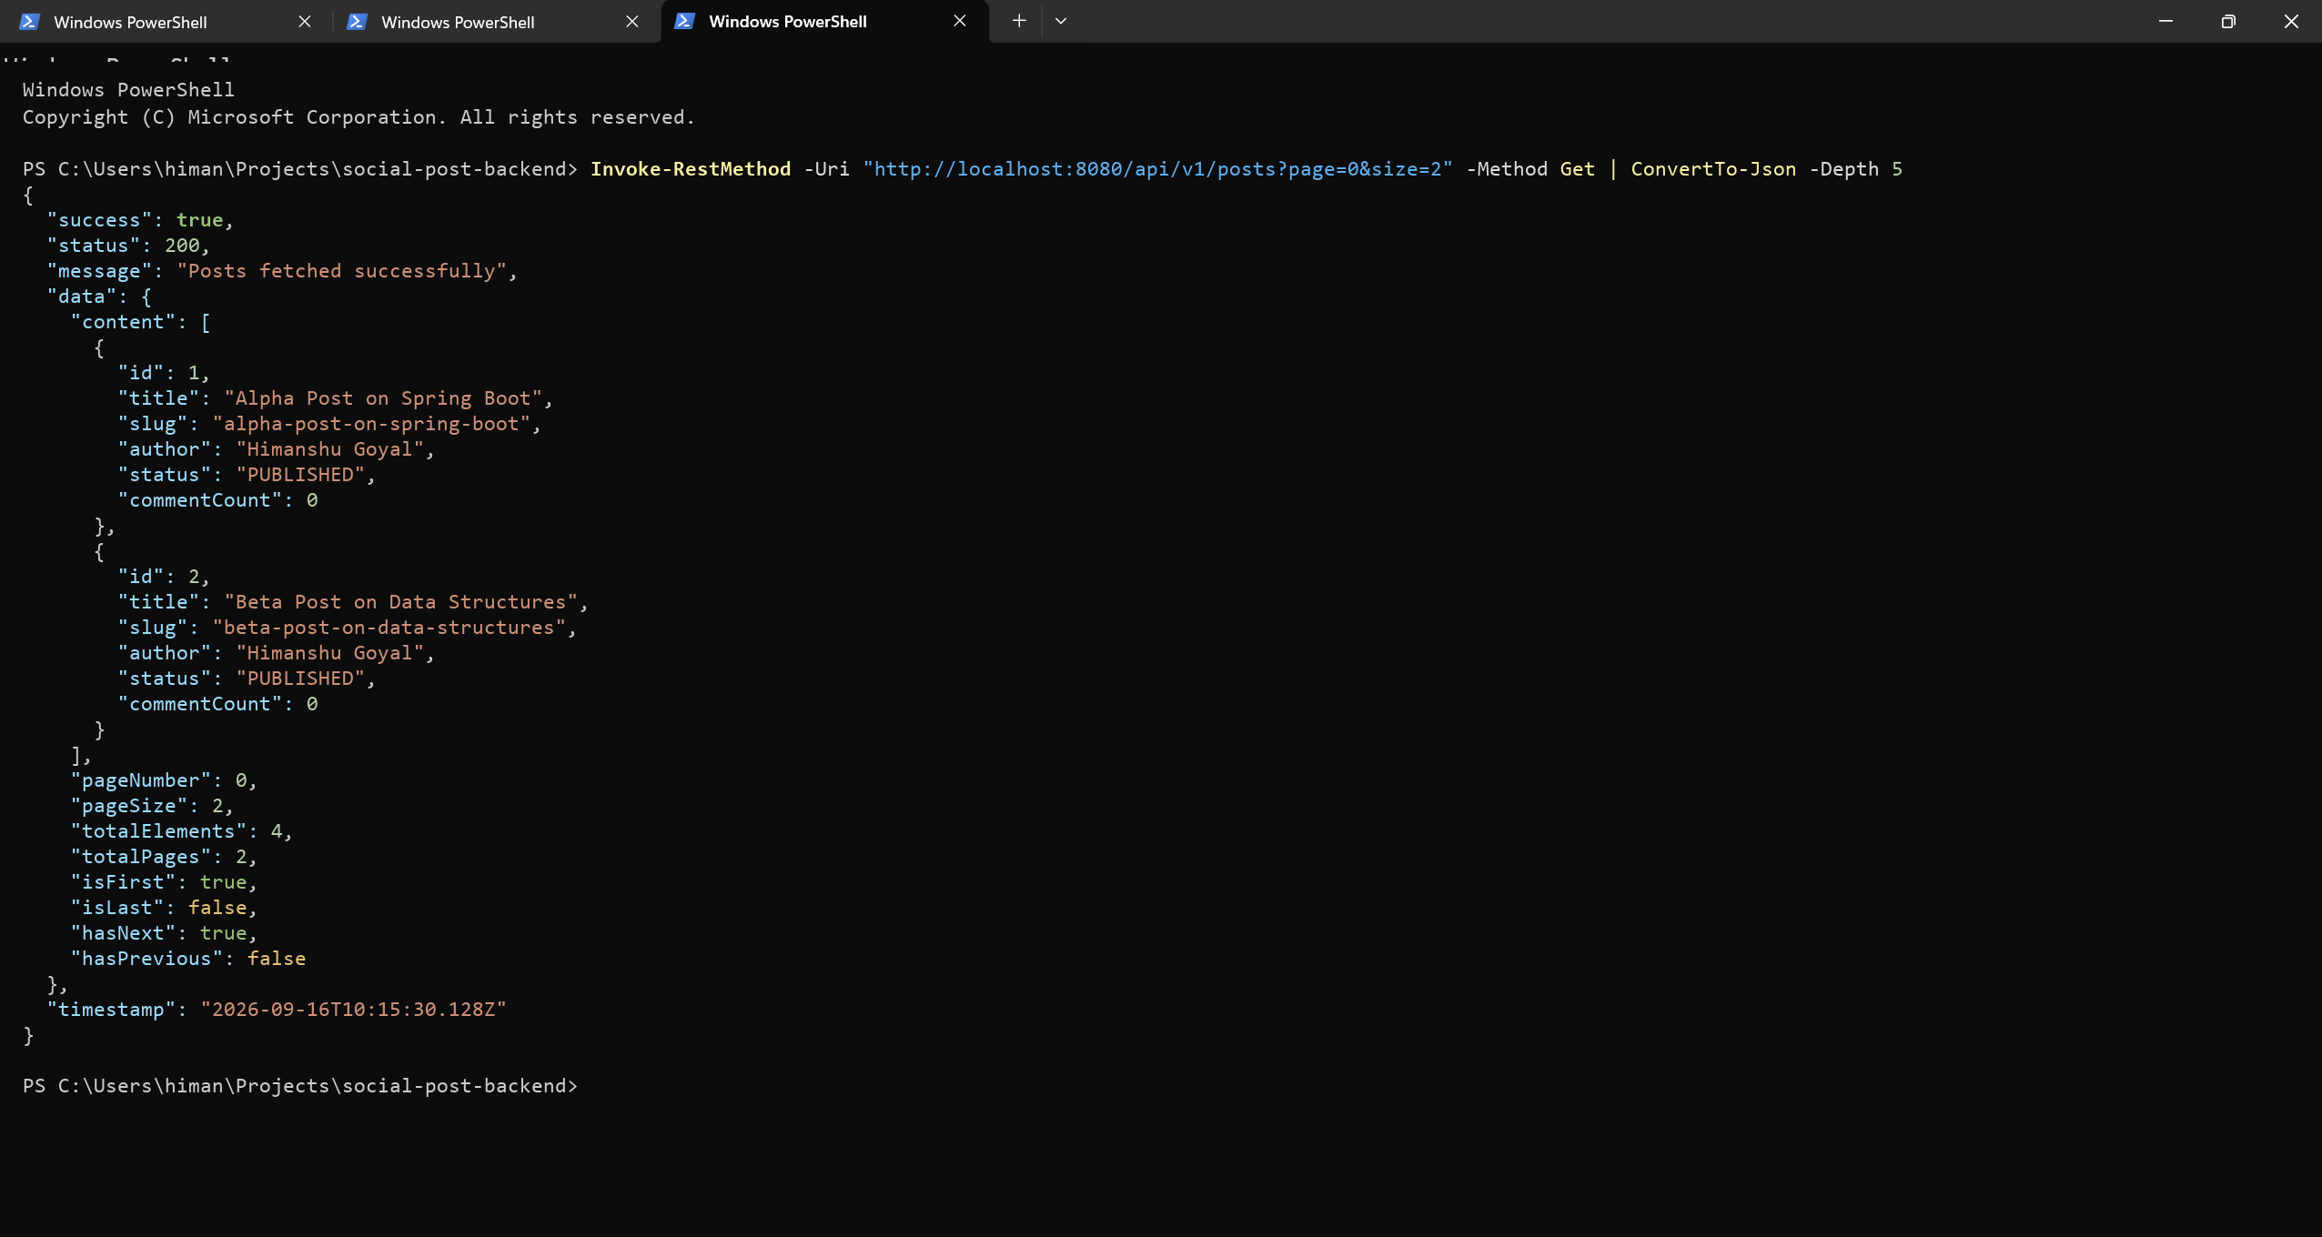
Output 2: Dynamic Multi-field Sorting (Title ASC) via Spring Data JPA Sort Object
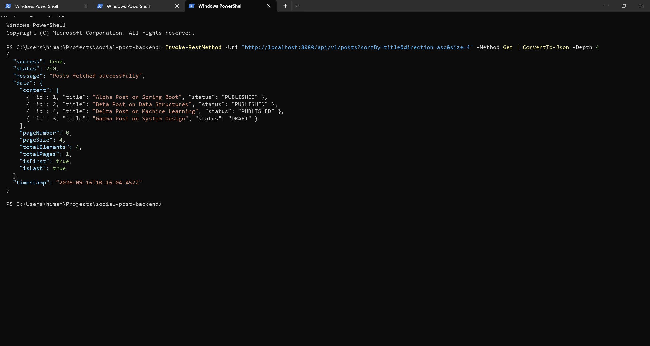
7. Conclusion:
Scalable read operations were successfully implemented using Spring Data JPA's Pageable and Sort abstractions. By enforcing strict pagination bounds (@Max(100)), the backend is protected against memory exhaustion and distributed denial-of-service vectors. Dynamic multi-field sorting empowers clients to organize feeds chronologically or alphabetically with sub-millisecond database queries. The standardized PagedResponse<T> metadata delivers comprehensive navigational context for responsive UI components, ensuring high performance.
8. Learning Outcomes:
• CO3 - BT3: Implemented paginated and sortable REST endpoints using Spring Data Pageable, PageRequest, and Sort.
• CO4 - BT4: Analyzed query performance and memory utilization under large datasets, mitigating unconstrained findAll() overhead.
• CO4 - BT4: Engineered structured PagedResponse envelopes containing navigational state flags (totalPages, hasNext, isFirst).
• CO3 - BT3: Applied defensive input bounds (@Min, @Max) to sanitize pagination request query parameters.

